

**Table of Contents**

|  |  |  |
| --- | --- | --- |
| **S.No.** | **Content** | **Page No.** |
| 01 | Objective and Introduction | 03 |
| 02 | About the project | 03 |
| 03 | Technology used | 04 |
| 04 | Features of the project | 05 |
| 05 | Implementation | 06 |
| 06 | Contribution of each team member | 12 |
| 07 | References | 13 |

**Objective of the Project**

To design a website for any real-world application (Jewellery shop website) using the concepts of HTML and CSS.

**Introduction**

The following PBL report contains information about 'ARMURA' an online jewellery store that members of our group created using HTML and CSS. Our goal was to make it simple for customers to choose and purchase jewellery as well as to comprehend the crucial tags and characteristics of HTML and CSS. The report consists of a straightforward explanation of how our website functions, explaining the many tags used to give it a more professional appearance. Additionally, in order to aid the reader's comprehension and understanding of our code, we have also provided the necessary screenshots of various bits and pieces of the entire website. For ease of use, comments have also been added to describe how several tags combine to form their corresponding feature on the specific webpage. Through the use of our report, the fundamental ideas of HTML and CSS, as well as how each of their various tags and attributes function, have been thoroughly explained.

**About the Project**

We wish to provide the user with an easy shopping experience through the website. Users can select the kind of jewellery item they want to explore on our website. Additionally, it has HTML and CSS features like adding items to the shopping cart and allowing users to save items they want to view later on a wish list. Aiming to allow proper interpretation of the code and easy use of the website, our goal was to make the website user friendly and robust. A webpage of feedback is another feature of the website that allows users to share their experience of using the website.

**Technology Used**

**HTML**

The preferred markup language for documents intended to be viewed in a web browser is HTML, or Hypertext Markup Language. Technologies including Cascading Style Sheets (CSS) and scripting languages like JavaScript can assist.

The foundation of HTML pages are HTML components. Images and other objects, like interactive forms, may be embedded within the produced page using HTML techniques. By indicating structural semantics for text elements like headings, paragraphs, lists, links, quotations, and other objects, HTML offers a way to generate structured texts. Tags, which are written in angle brackets, are used to distinguish HTML elements. Input and image tags, for example, add content directly to the page. Other tags, like <p>, enclose and describe the text of the document. They may also contain other tags as sub-elements. Browsers employ the HTML tags to decipher the page's content rather than displaying them.

**CSS**

The style sheet language known as Cascading Style Sheets (CSS) is used to describe how a document written in a markup language like HTML is presented.

The purpose of CSS is to make it possible to separate content from presentation, including layout, colors, and fonts.  By specifying the pertinent CSS in a separate.css file, which reduces complexity and repetition in the structural content, this separation can improve content accessibility, provide more flexibility and control in the specification of presentation characteristics, enable multiple web pages to share formatting, and enable the.css file to be cached to improve page load speed between the pages that share the file and its formatting.

**Features of the Project**

The main aim of the website is to display the webpage of a jewellery shop where one can view and select the jewellery they like.

The main webpage displays the name of the jewellery shop along with a short description.

The navigation bar includes the logo of the shop and several options to view categories, the cart, contactors page and the main homepage.

On the clicking the ‘shop by’ category option in the navigation bar, the website will skip to the various categories provided by the shop – anklets, earrings, bracelets, rings and necklaces.

On clicking any of the category, a new page opens which displays all of the products that are available in the selected category.

For example, when we click on the rings category a new page will open that will display all the available types and designs of rings.

As per our preferences we can also select the jewellery we want to add to our cart or wish list.

The ‘add to cart’ option, redirects the web page to the customer information page and feedback can also be given by clicking the ‘contact us’ button.

**Implementation**

Homepage

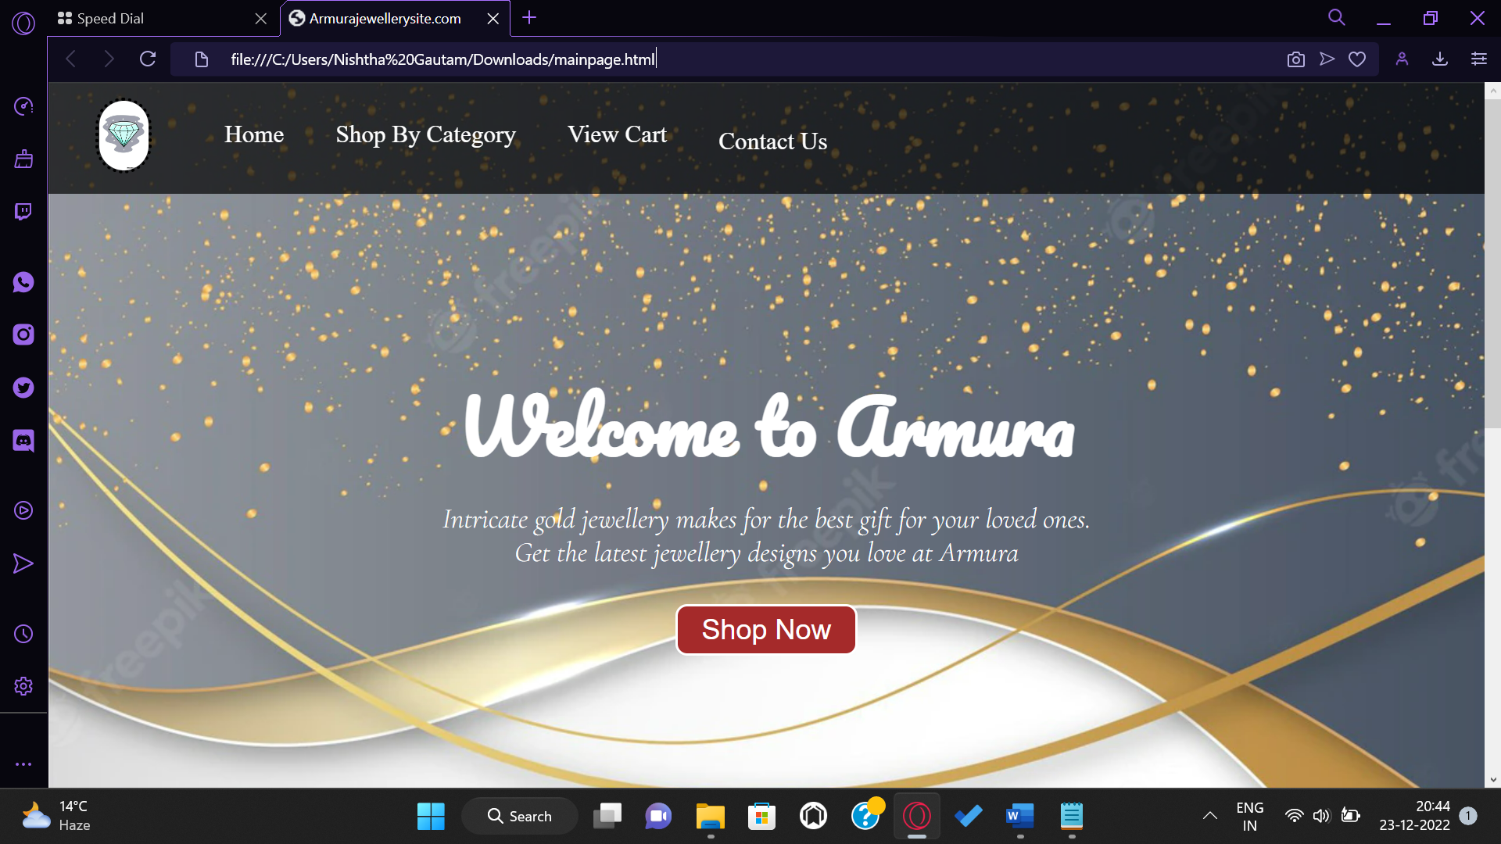

When scrolled

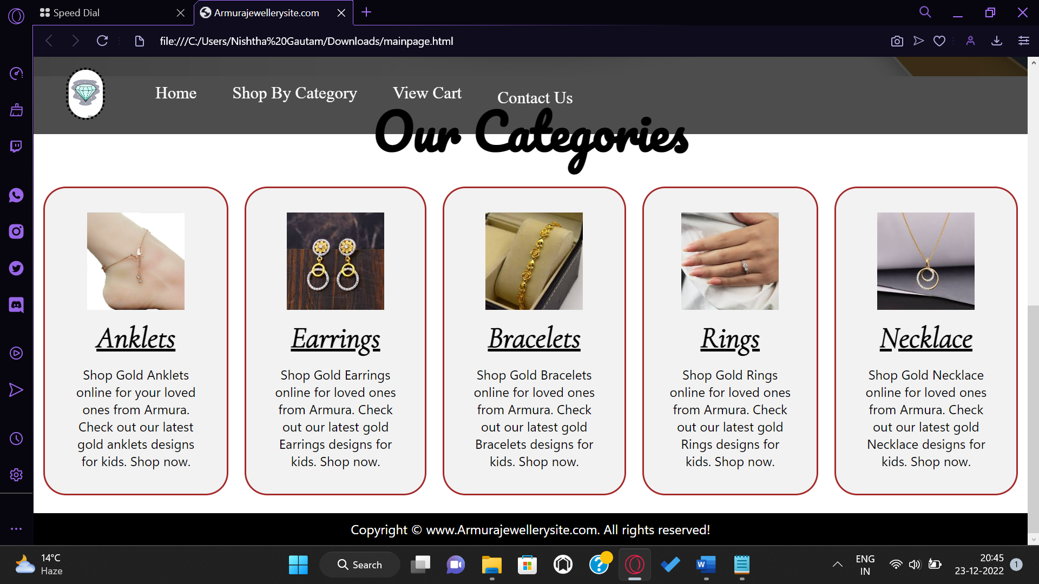

When clicked on ‘anklets’

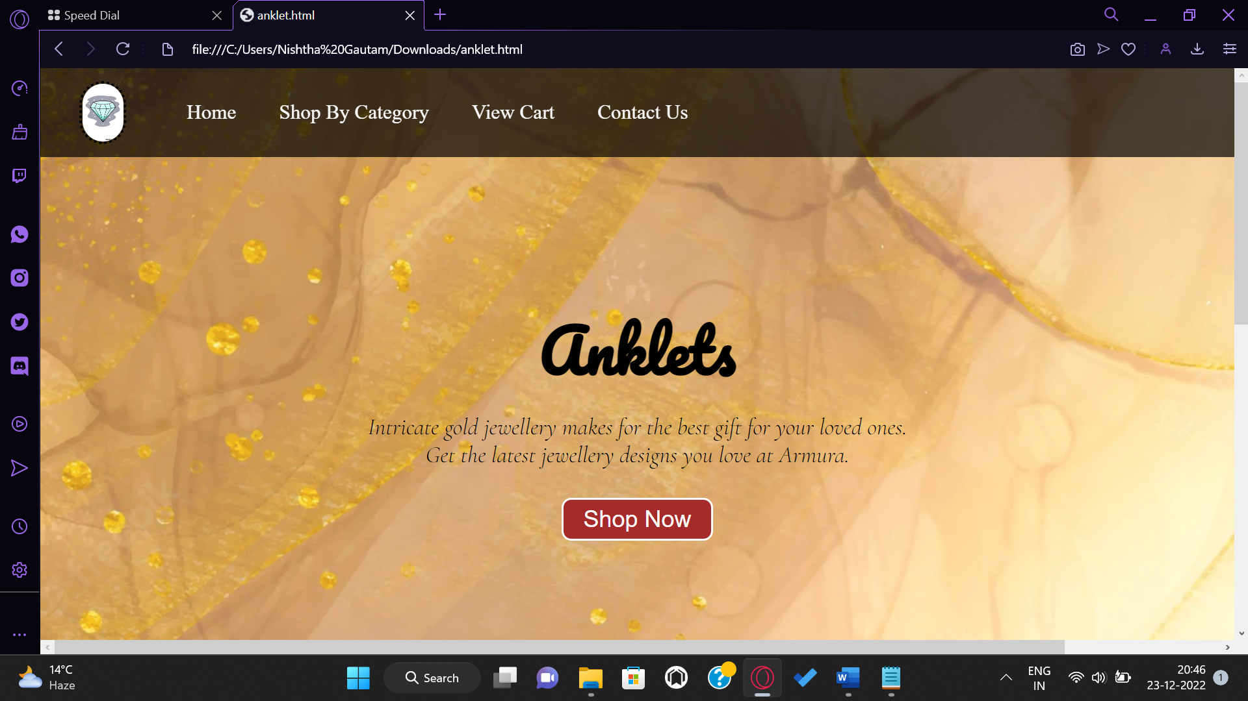

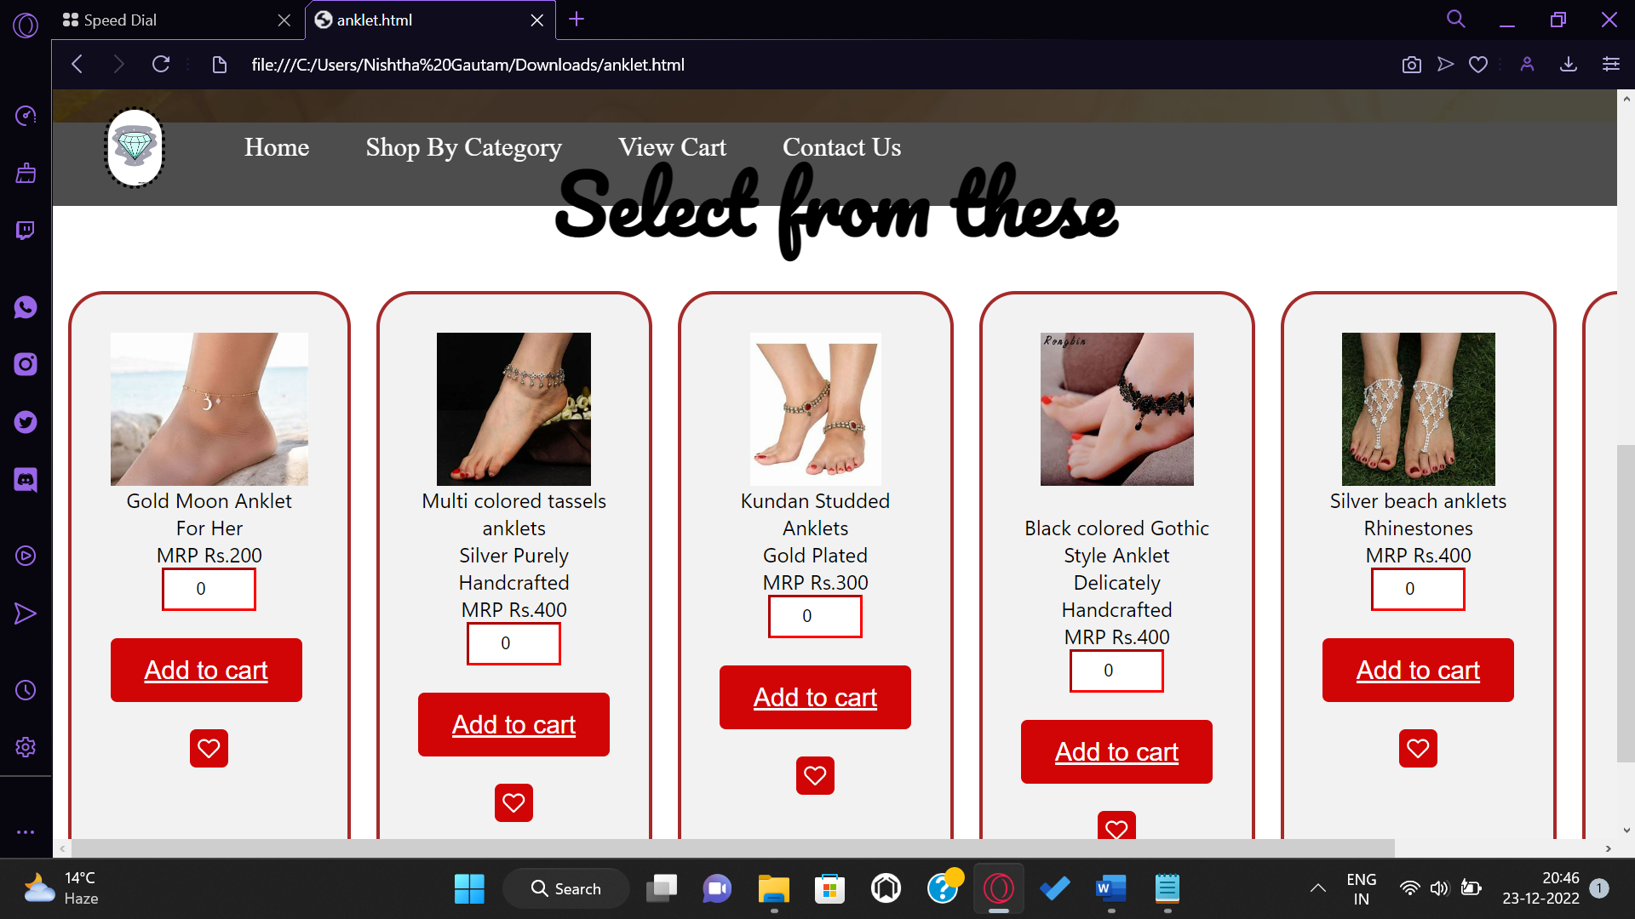

* you can increase or decrease the quantity of the product as per your preference
* you can zoom in on the pictures by simply hovering over them.
* The cursor changes to pointer when hovered over the ‘Add to cart’ option.
* The ‘wish list’ icon is zoomed in when clicked.

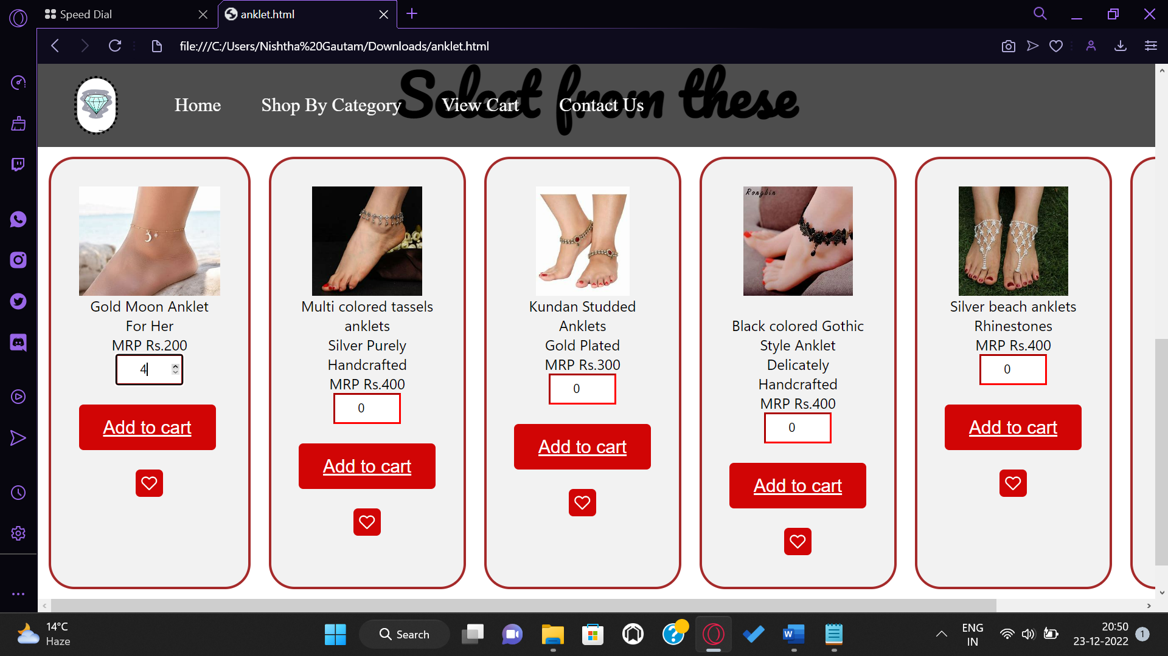 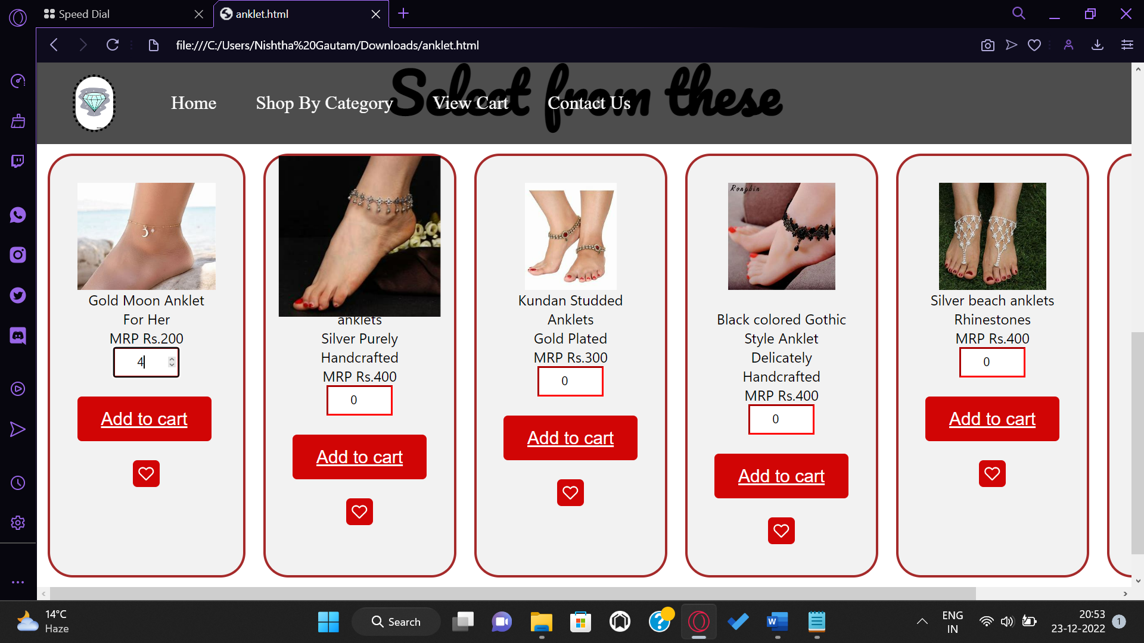 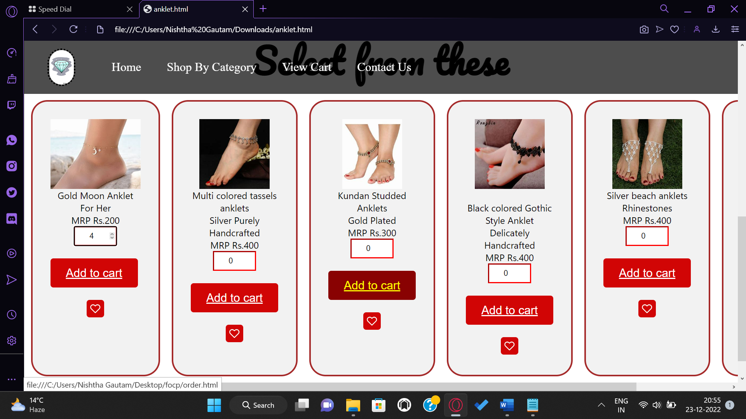

When clicked on ‘earrings’

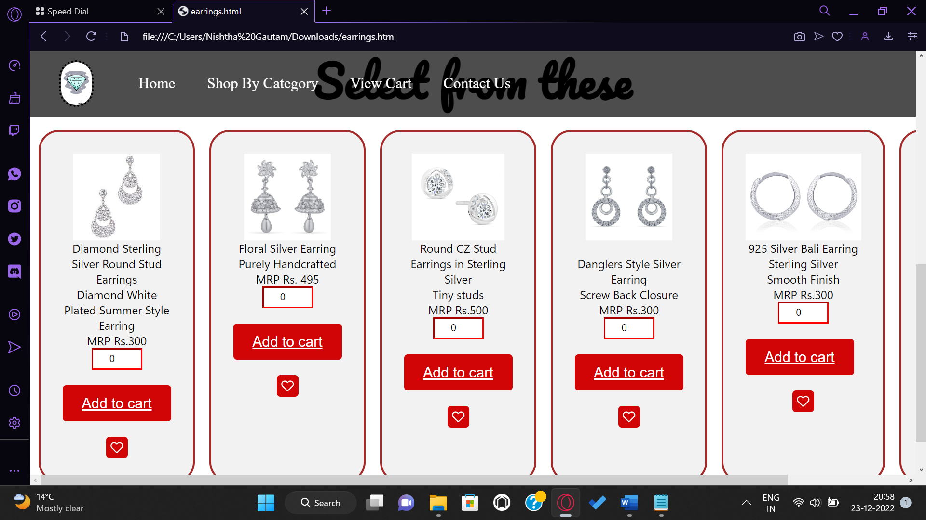

When clicked on ‘bracelets’

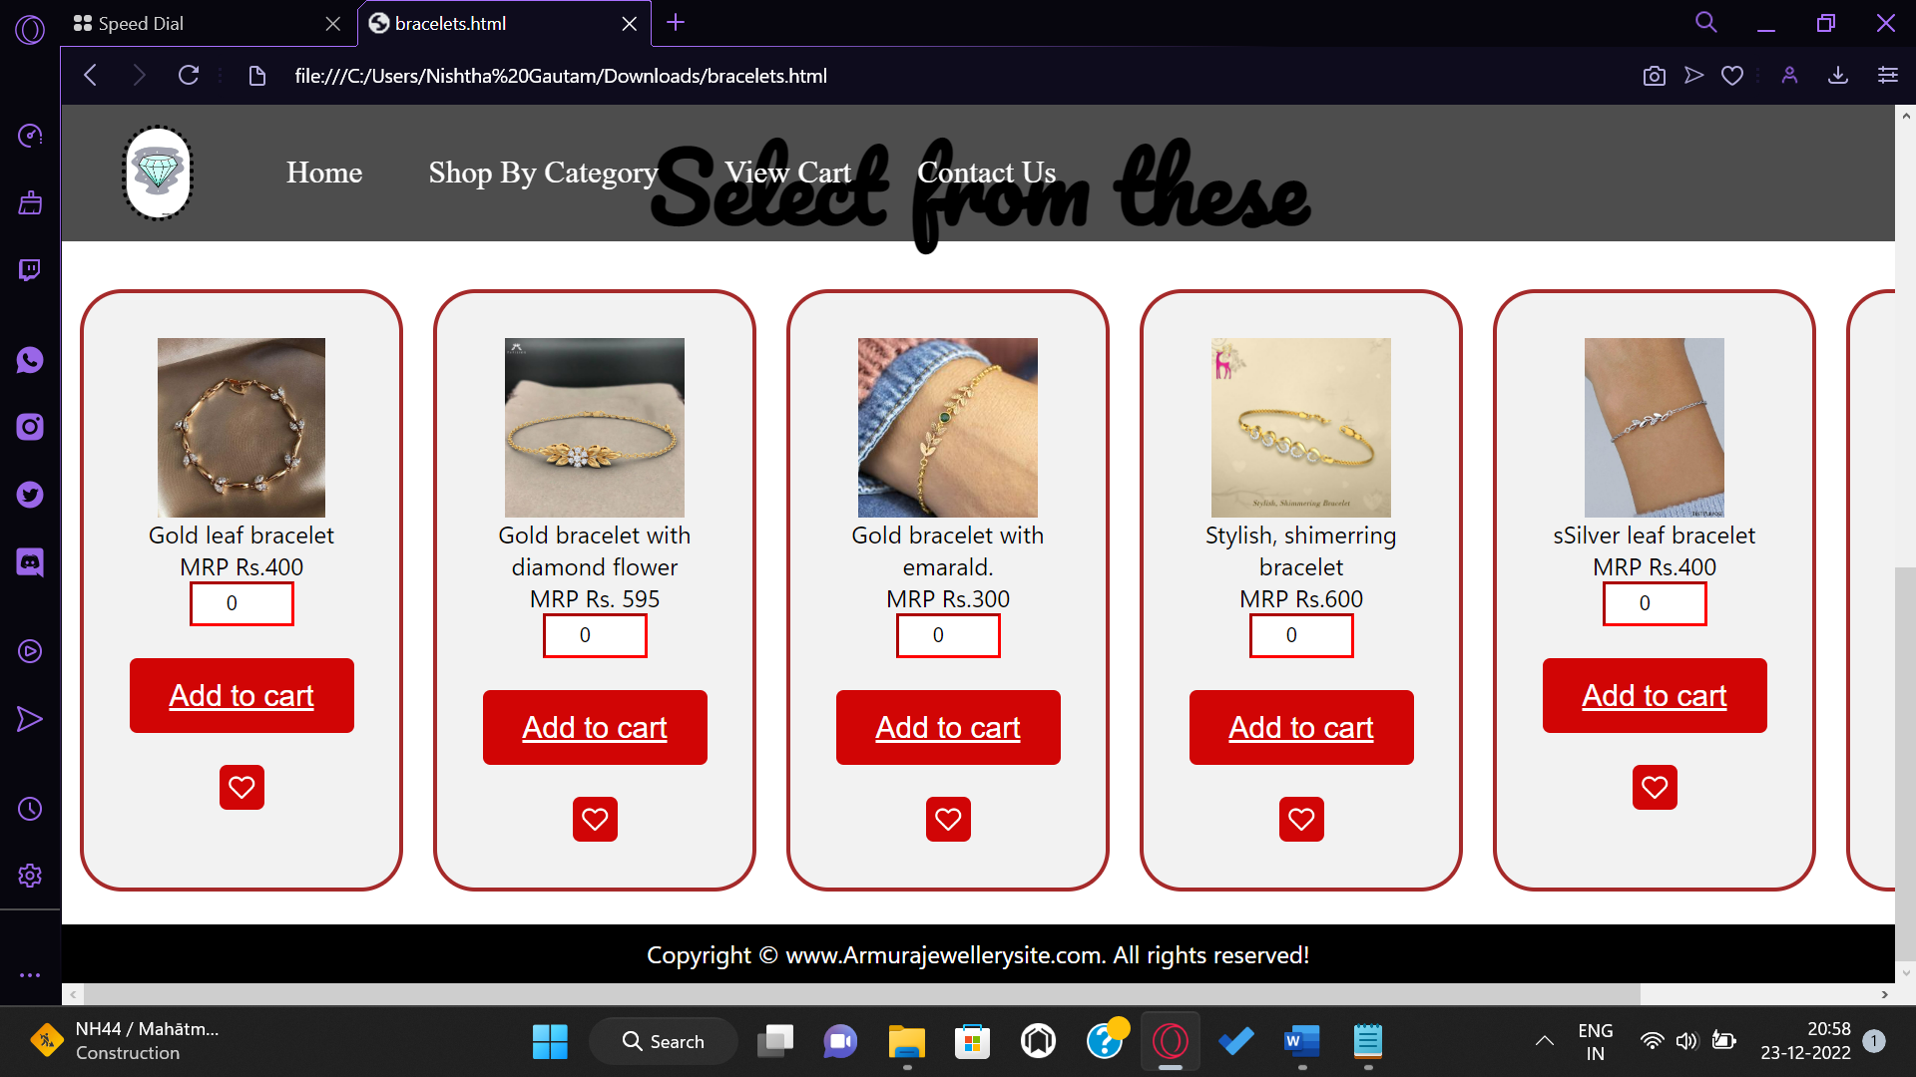

When clicked on ‘rings’

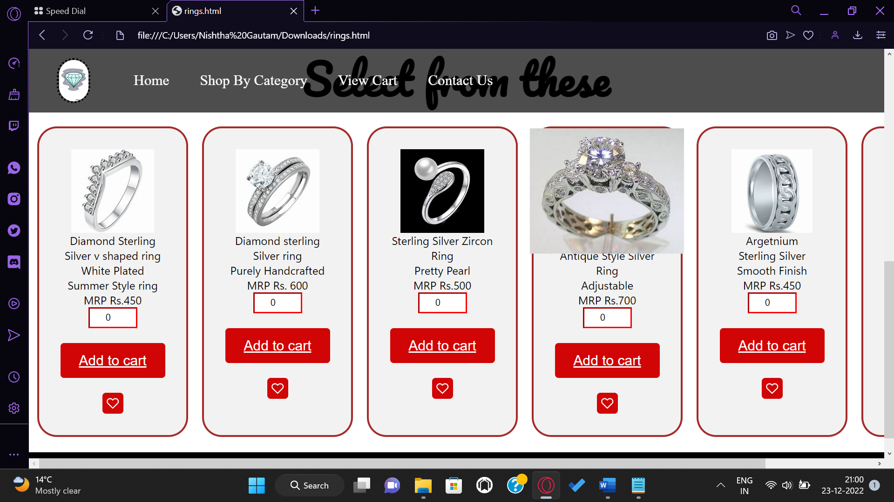

When clicked on ‘necklaces’

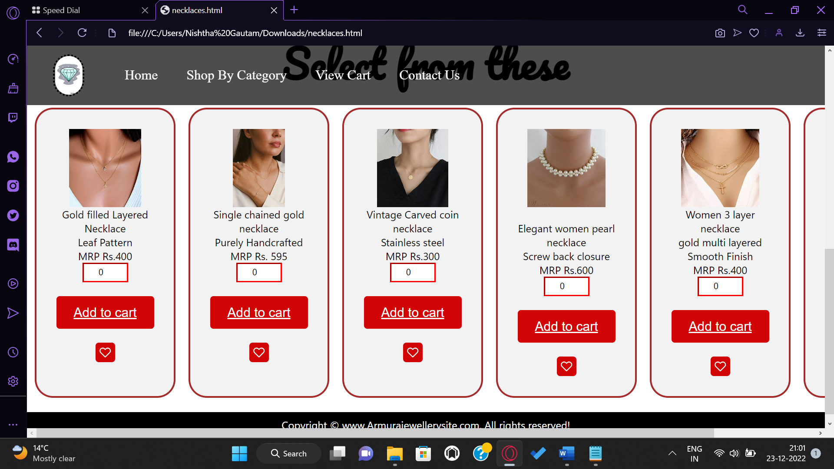

The add to cart option redirects you to the customer information page

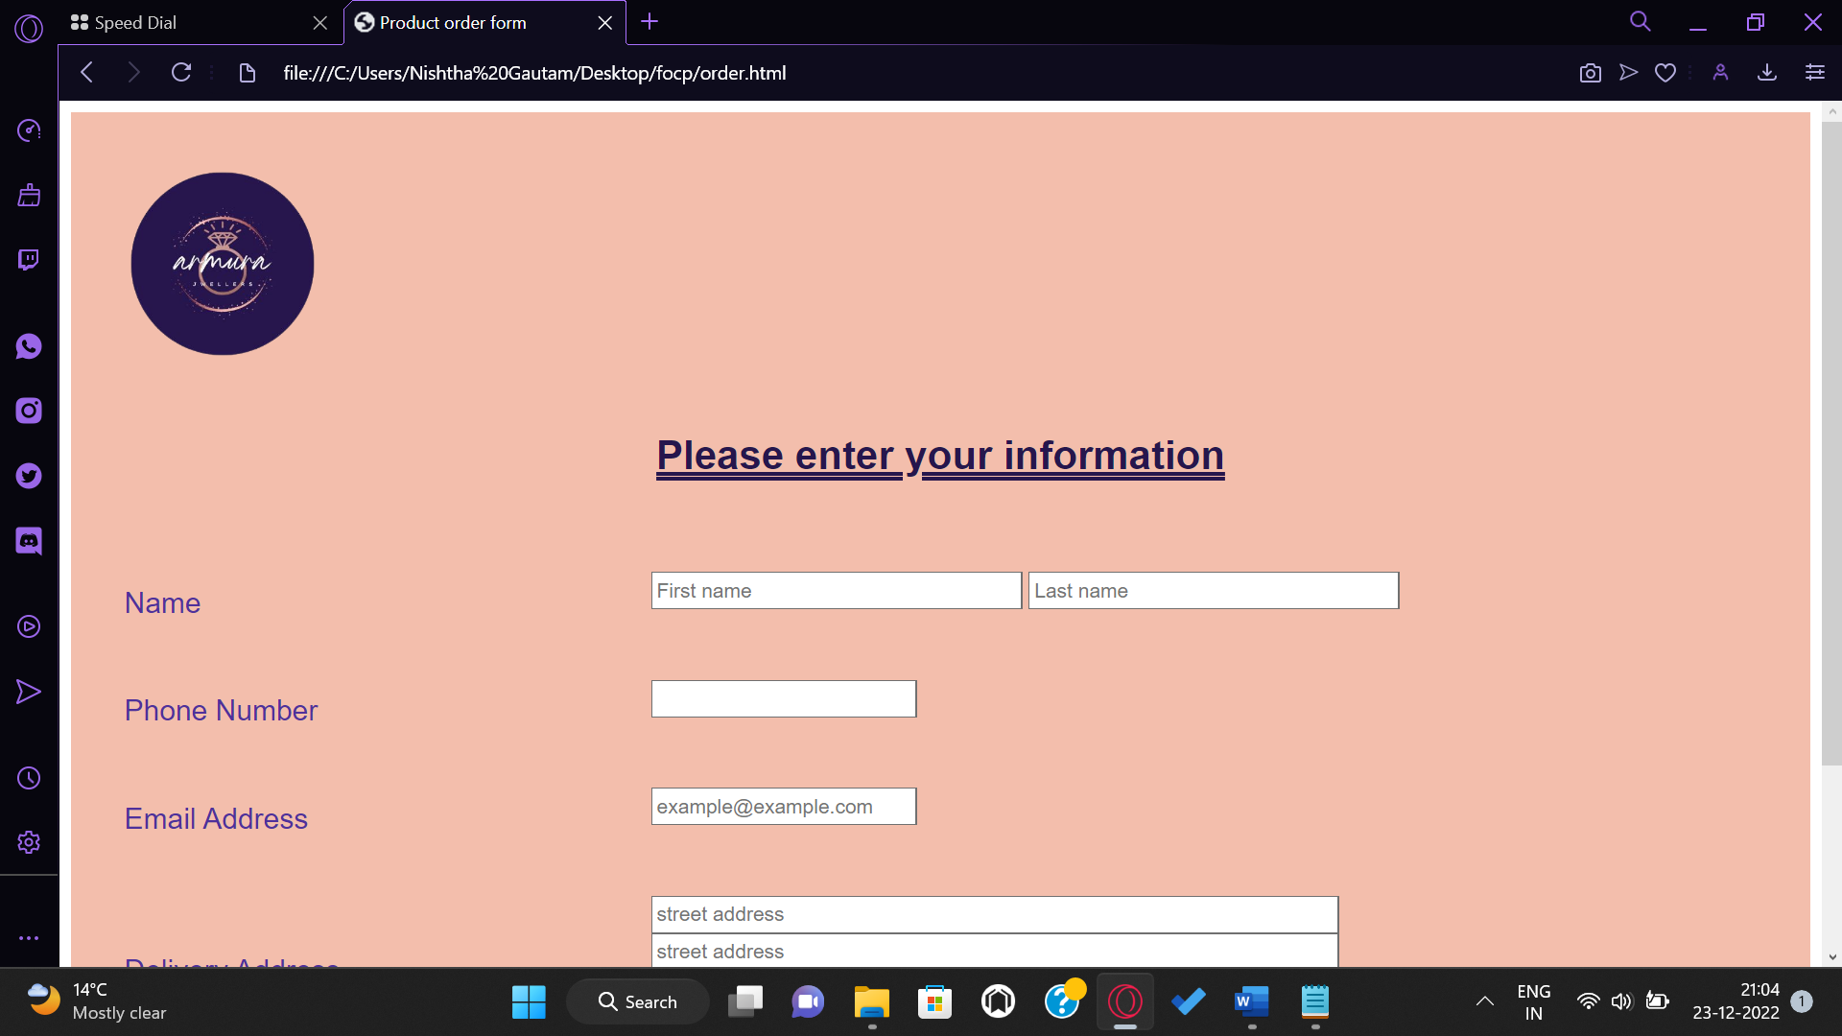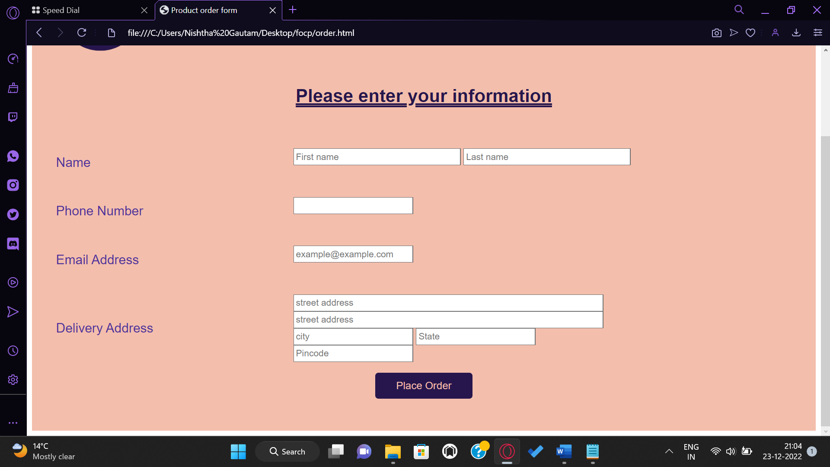

you can give us feedback by clicking on the contact us button on the homepage

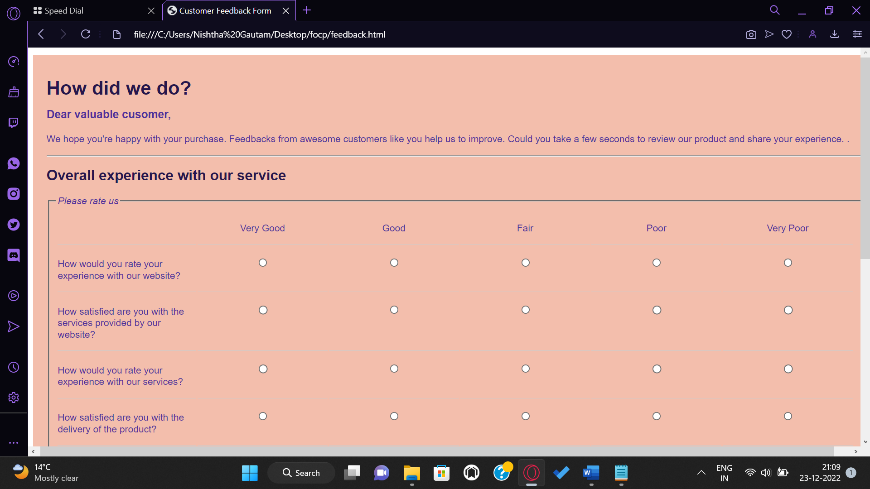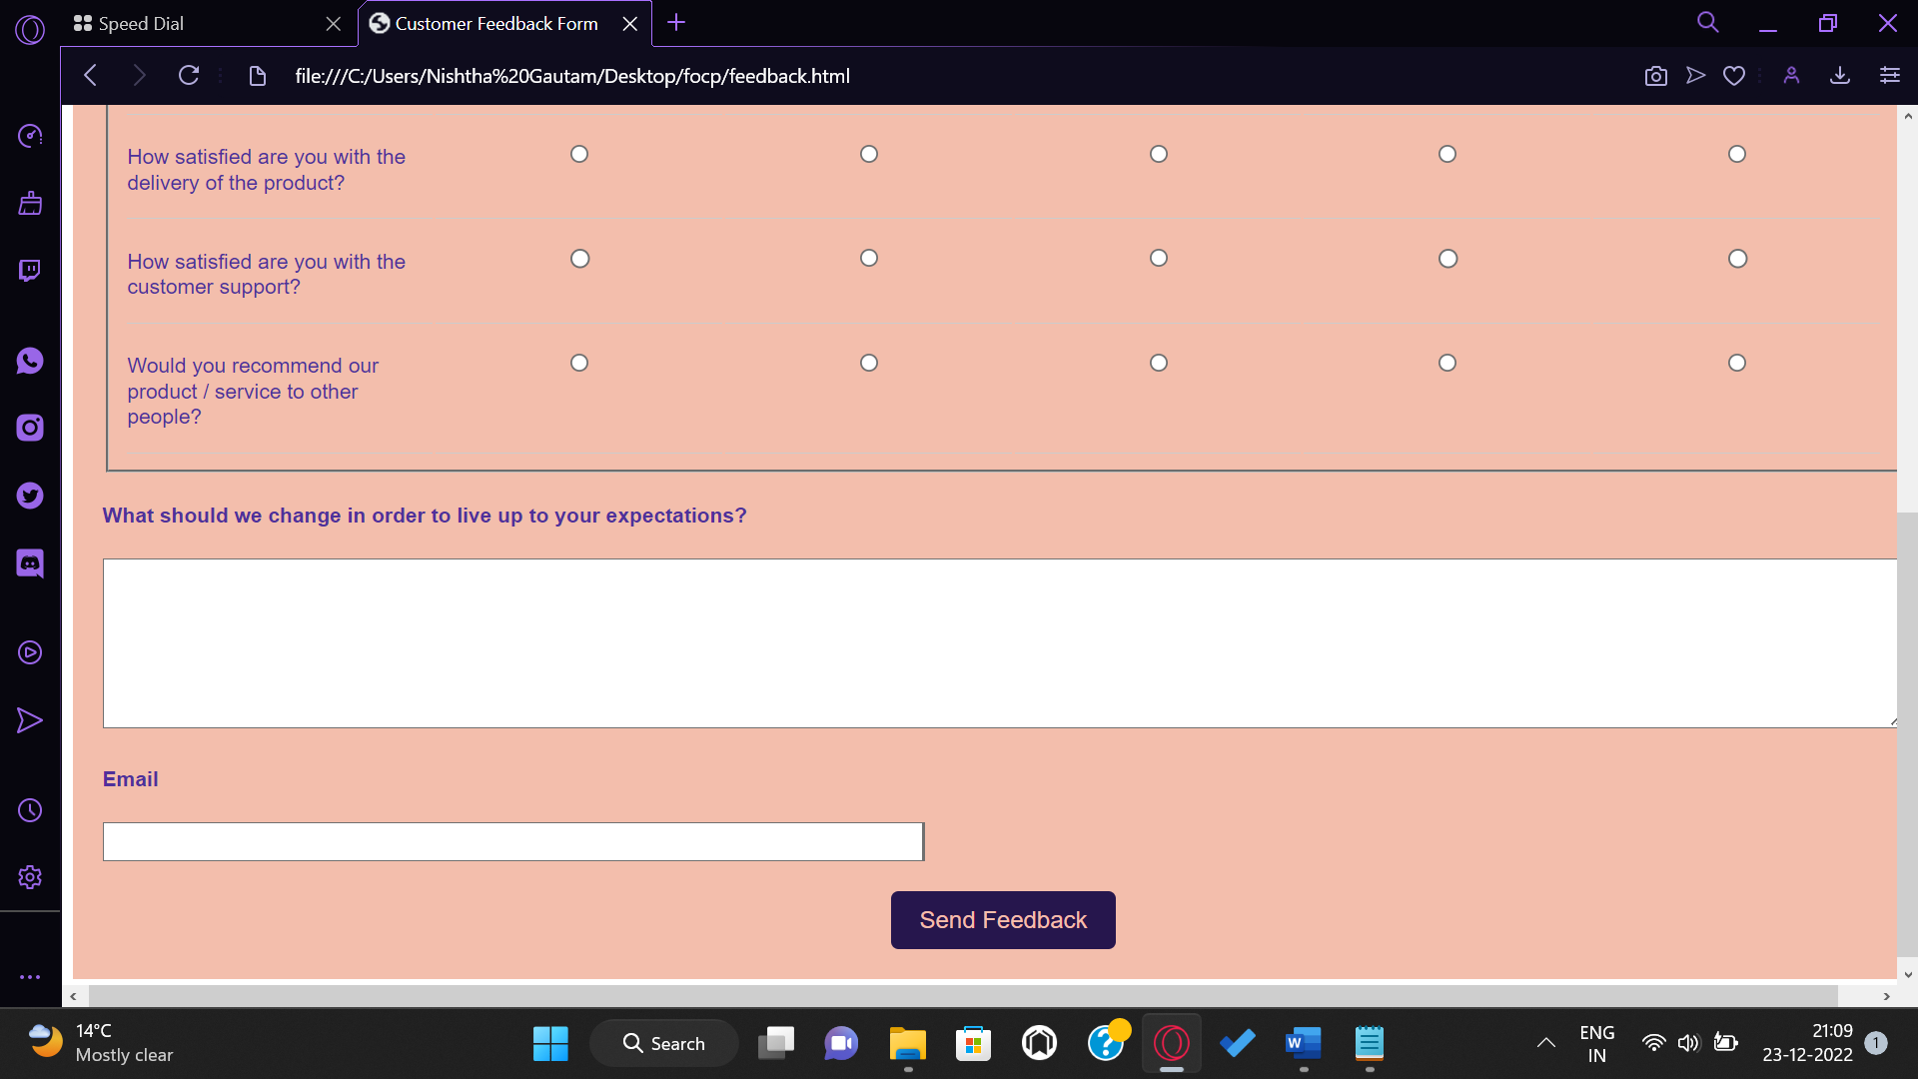

**Contribution of members of the team**

Each team member received an equal share of the workload. To create this website, we have all given our best effort. The work that each participant contributed is listed in the section below.

**Arpita Srivastava(BTG220090)-**

* HTML code for the main web page.
* CSS code for the main webpage.
* CSS code for all the jewelry pages.

**Nishtha Gautam (BTG220070)-**

* Adding add to cart and wish list options to the products.
* Webpage for customer information and feedback page.
* Stylesheet for the customer information and feedback page.

**Shubhanjali Singh (BTG2200109) and Shreya Bhargava (BTG220103)-**

* Enlisting the products and writing their description.

**References**

* <https://www.w3schools.com/html/>
* <https://www.w3schools.com/css/default.asp>
* <https://www.geeksforgeeks.org/top-10-projects-for-beginners-to-practice-html-and-css-skills/>
* <https://html.com/>
* <https://www.w3.org/Style/CSS/Overview.en.html>
* <https://www.canva.com/>